Web Application Pen-Testing

AY 2022/2023

Week 3.1 Practical

OWASP Top 10 - 2021

A01:2021-Broken Access Control

Part 1

Vertical Privilege Escalation

(Non-Admin 🡪 Admin)

Document Version: 1

Tools covered:

* Enumeration Tools: OWASP ZAP
* Exploitation Tools: ZAP, Burp Suite

Table of Contents

1 Setup 3

1.1. Start and Login to Kali Linux VM with NAT enabled 3

1.2. Update Burp Suite 4

1.3. Update OWASP ZAP 5

1.4. Importing OWASP ZAP’s Server Certificate into Kali Linux Web Browser as a Trusted CA 7

1.5. Importing Burp Suite’s Server Certificate into Kali Linux Web Browser as a Trusted CA 11

1.6. Enabling Kali Linux Web Browser Proxy Settings 12

1.7. Sign up and Login at WebSecurity Academy – by PortSwigger (Creators of Burp Suite) 13

2 Vertical privilege escalation 14

2.1. Unprotected functionality 14

**2.1.1.** **Lab 1: Unprotected admin functionality** 15

**2.1.2.** **Lab 2: Unprotected admin functionality with unpredictable URL** 19

2.2. Parameter-based access control methods 23

**2.2.1.** **Lab3: User role controlled by request parameter** 23

**2.2.2.** **User role can be modified in user profile** 31

|  |  |
| --- | --- |
|  |  |

## Update OWASP ZAP

Before you launch OWASP ZAP, make sure that **Burp Suite is not running (Quit/Terminate Burp Suite)**. Launch ZAP, click on “Learn More”

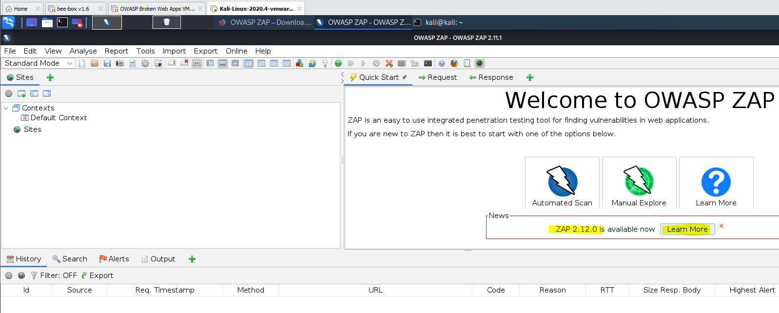

Next to “Linux Installer”, click “Download”

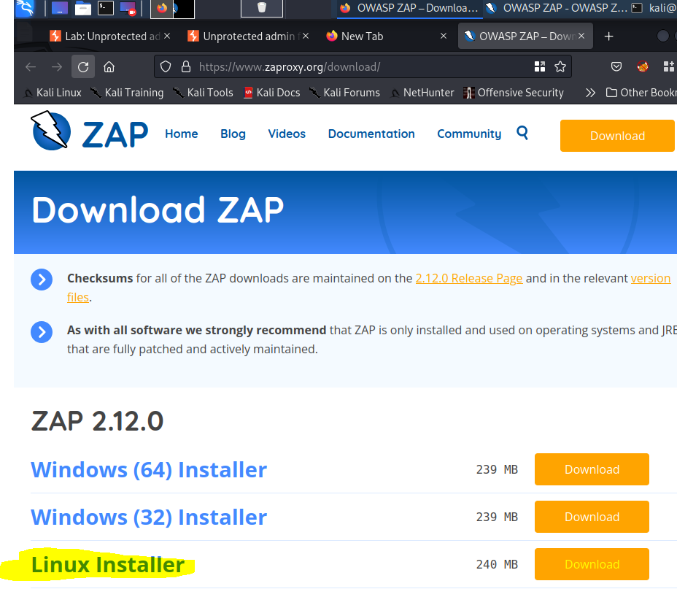

Go to “/home/kali/Downloads/” and right-click “Open Terminal Here”

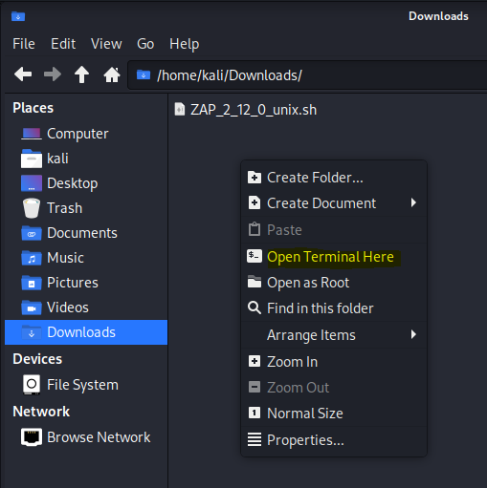

Type the following command into the Kali Linux’s Terminal Emulator and press Enter. Complete the installation procedure.

sudo bash ZAP_2_12_0_unix.sh

|  |  |
| --- | --- |
|  |  |
|  |  |
|  |  |
|  |  |

## Importing OWASP ZAP’s Server Certificate into Kali Linux Web Browser as a Trusted CA

#### Launch OWASP ZAP

Before you launch OWASP ZAP, make sure that **Burp Suite is not running (Quit/Terminate Burp Suite)**. Click on Kali Linux logo at the top left corner of the Desktop, and search for “ZAP”. Click on “OWASP ZAP” to launch the OWASP ZAP. NOTE: The other ZAP you may see on the top is your older version.

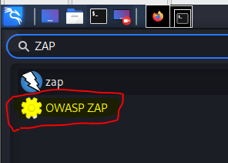

Select: No, I do not want to persist this session at this moment in time, and Click “Start”

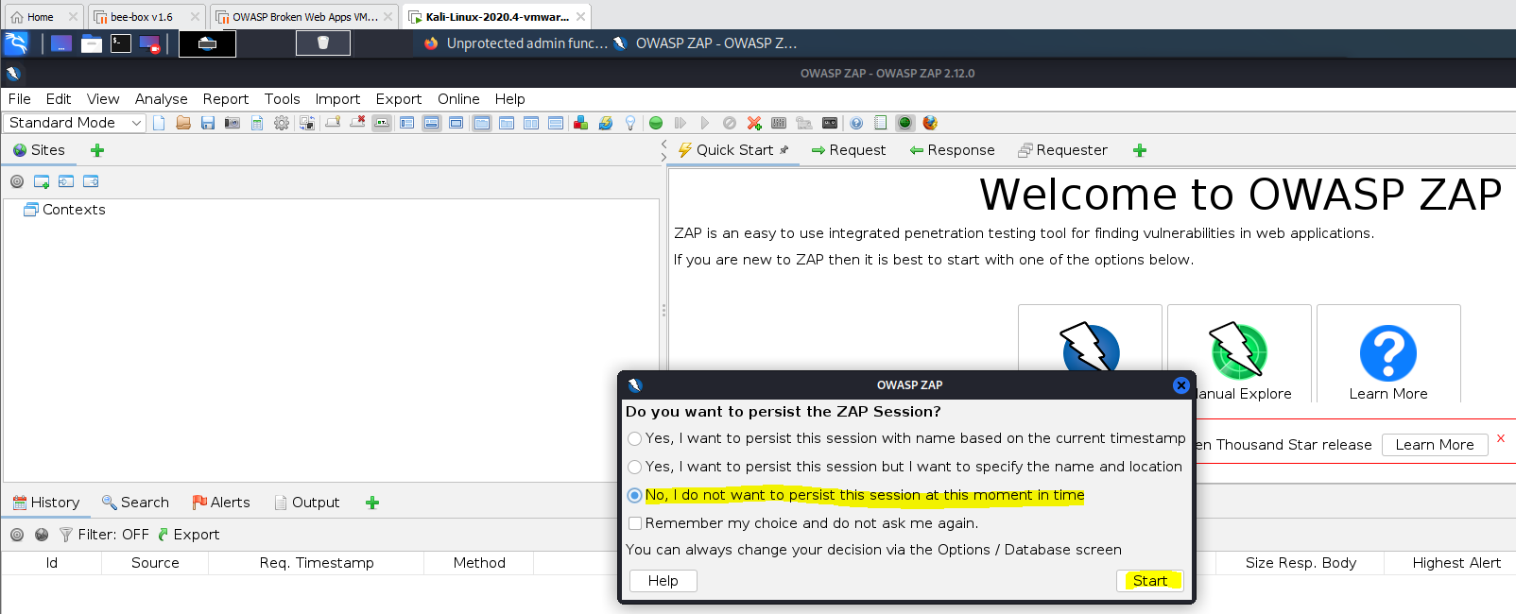

Click on “Tools” and Select “Options…”

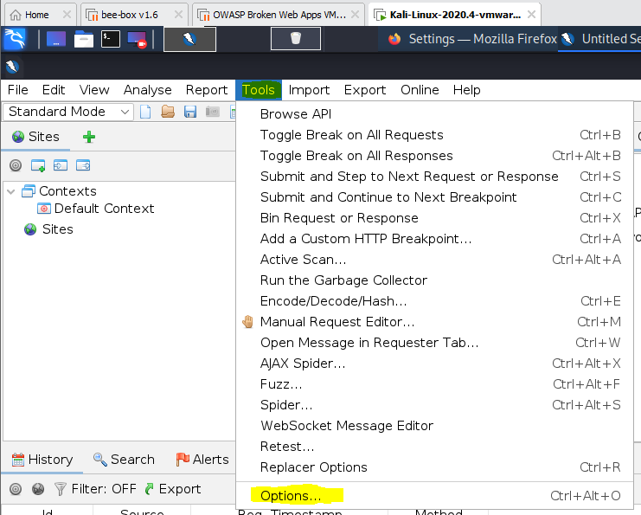

#### Obtain OWASP ZAP’s Server Certificate

On the left, scroll down, click “Network”, select “Server Certificates”, and click “Save”

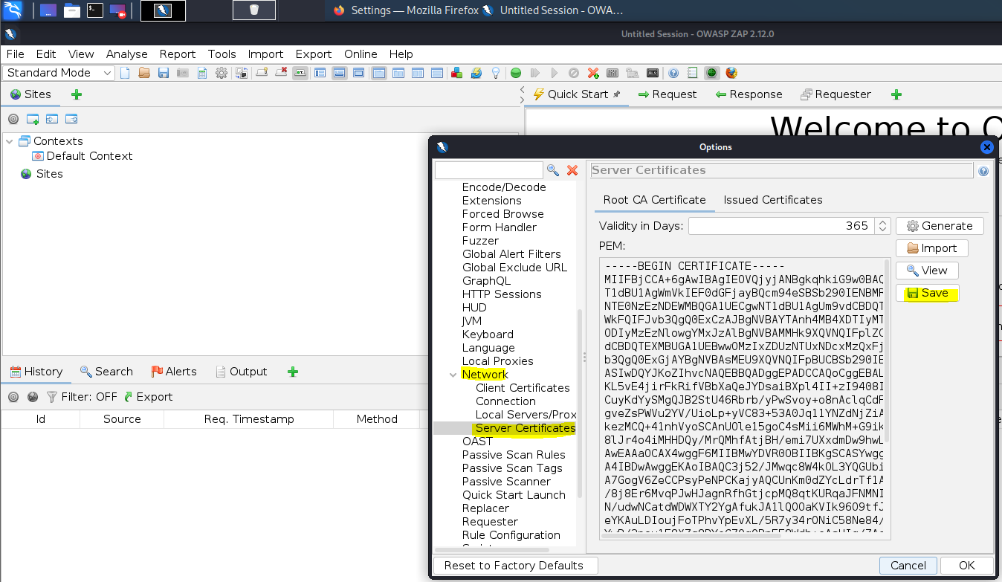

Save OWASP ZAP’s Server Certificate on the “Desktop”: Click “Open”, and then in the next window click “Save”.

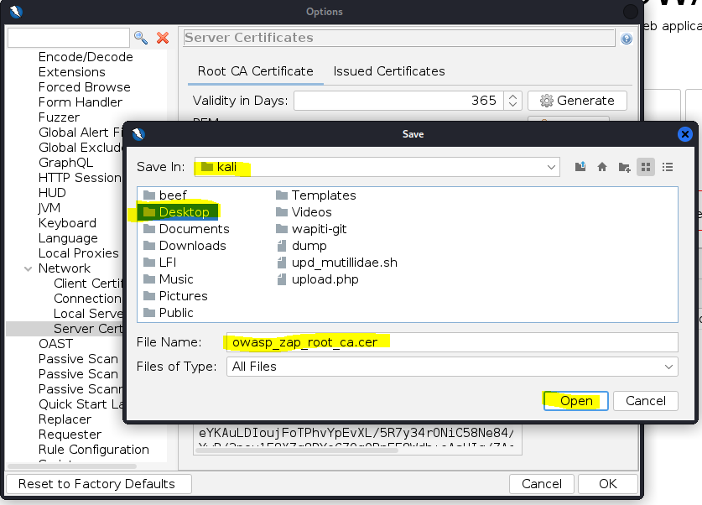

#### Import OWASP ZAP’s Server Certificate into Kali Linux Web Browser as a Trusted CA

In the Kali Linux Web Browser, click on the right-hand top corner hamburger icon and click on “Settings“.

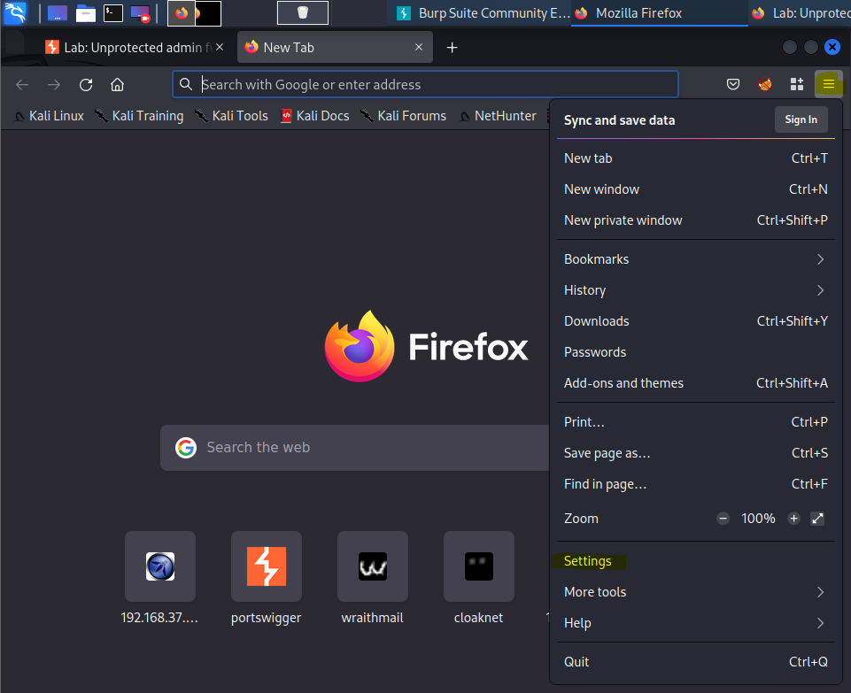

Type “certificate” in the search field and click on “View Certificates…”

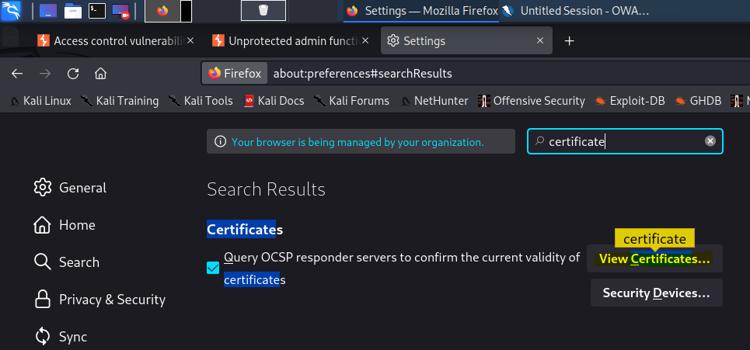

Under the “Authorities” tab, click “import” and select the OWASP ZAP’s Server Certificate, that we saved on the Desktop, and click “Open”

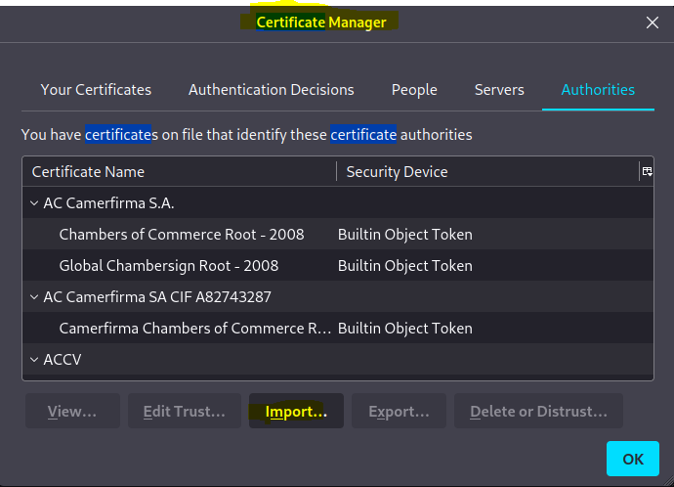

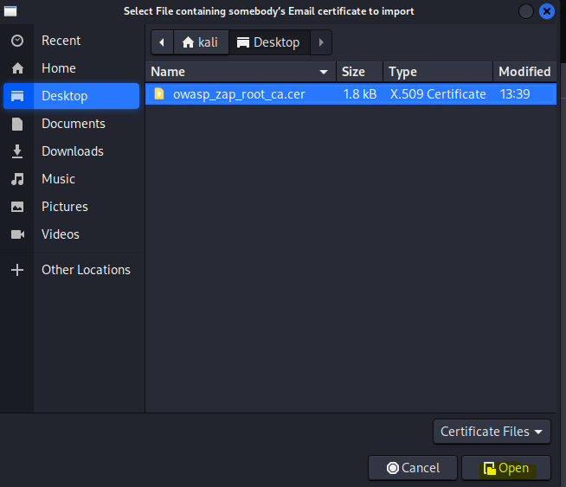

Select “Trust this CA to identify websites”, click “OK”, and click “OK” on the next window as well.

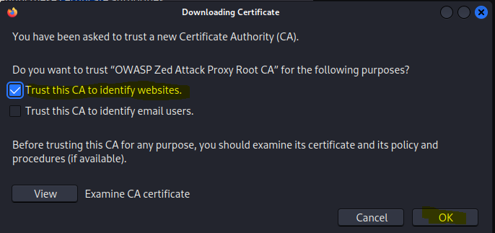

Type “certificate” in the search field and click on “View Certificates…” to make sure.



You can see under the “Authorities” tab, OWASP Root CA is listed

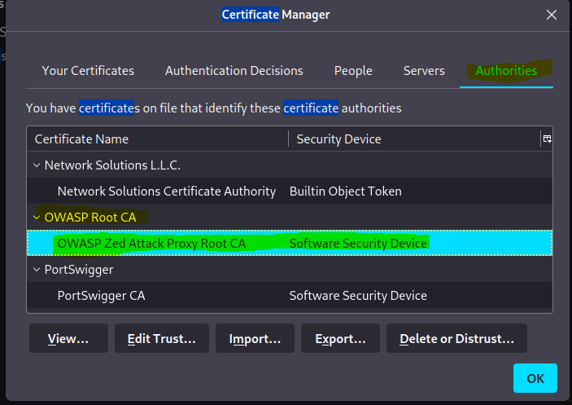

## Importing Burp Suite’s Server Certificate into Kali Linux Web Browser as a Trusted CA

#### Launch Burp Suite

Before you launch Burp Suite, make sure that **OWASP ZAP is not running (Quit/Terminate OWASP ZAP)**. Click on Kali Linux logo at the top left corner of the Desktop, and search for “burp”. Click on “Burp Suite Community Edition” to launch the Burp Suite

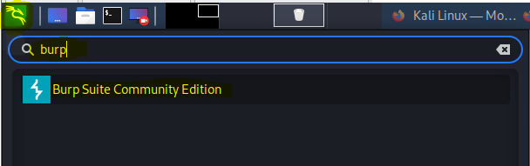

#### Obtain Burp Suite’s Server Certificate

Launch Kali Linux Web Browser. Type in the address bar: 127.0.0.1:8080. Once the page is loaded, click on the link “CA Certificate” located at the top right corner. Immediately the CA Certificate (“cacert.der”) is downloaded into the “Downloads” folder.

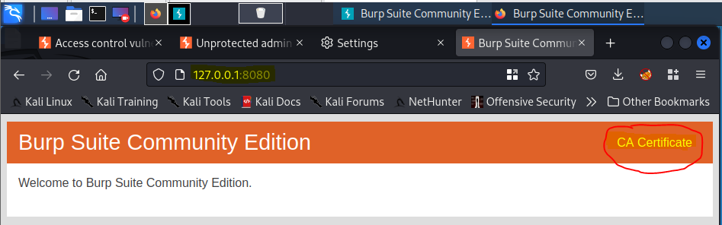

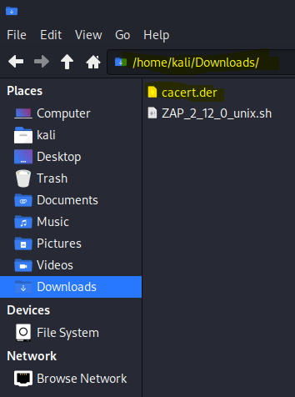

From here onwards follow the same procedure as described above for OWASP ZAP to add its Server Certificate as a trusted CA. After you have successfully “Imported” Burp Suite’s CA Certificate into Kali Linux Web Browser’s Certificate Manager under “Authorities”, it should look like the screenshot shown below.

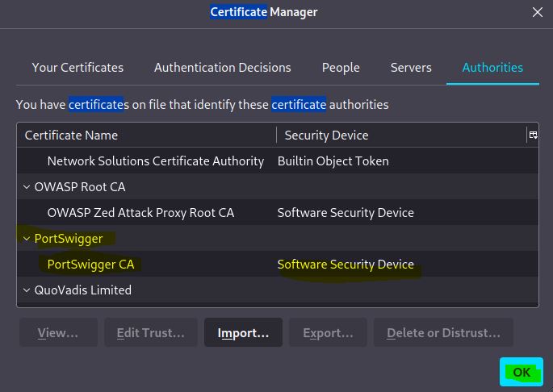

## Enabling Kali Linux Web Browser Proxy Settings

In the Kali Linux Web Browser, click on the right-hand top corner hamburger icon and click on “Settings“.



Type “proxy” in the search field and click on “Settings…”

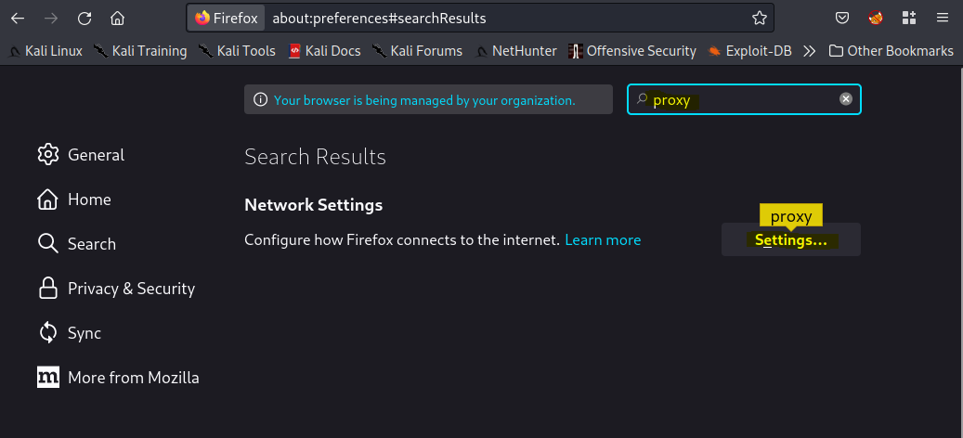

Select “Manual proxy configuration” and under “HTTP Proxy” type “127.0.0.1” and under “Port” type 8080 and click “OK”.

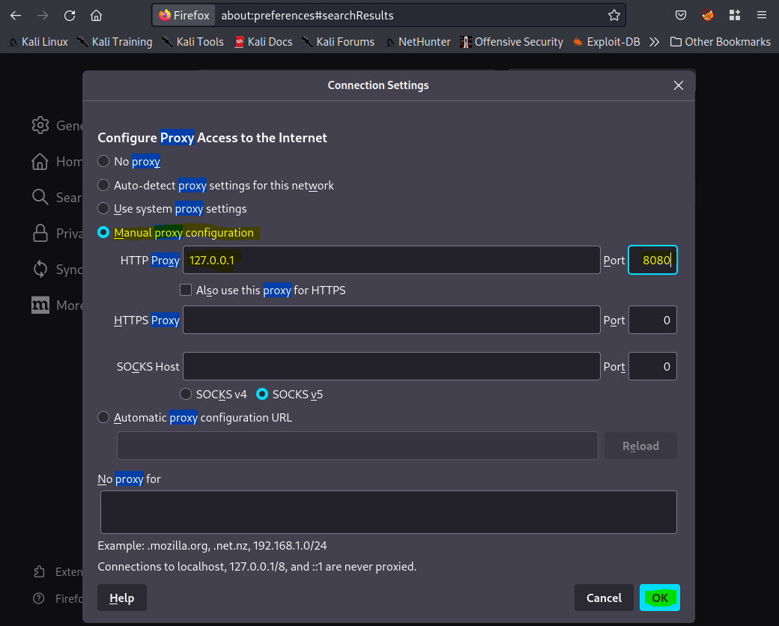

## Sign up and Login at WebSecurity Academy – by PortSwigger (Creators of Burp Suite)

URL: <https://portswigger.net/web-security>

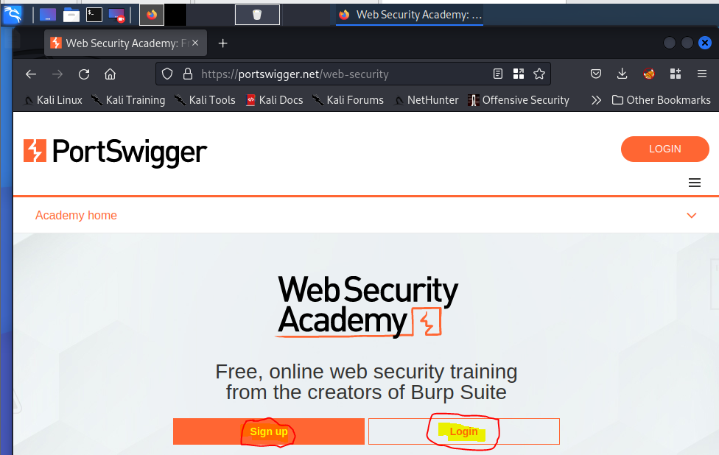

After Login click “Academy” on the top menu bar.

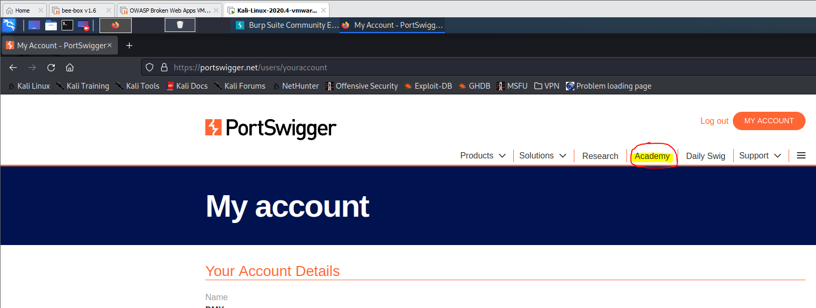

Click on “Learning Path” on the top menu bar.

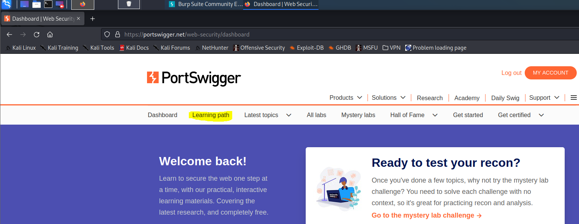

Scroll down and click on “7 Access Control” block

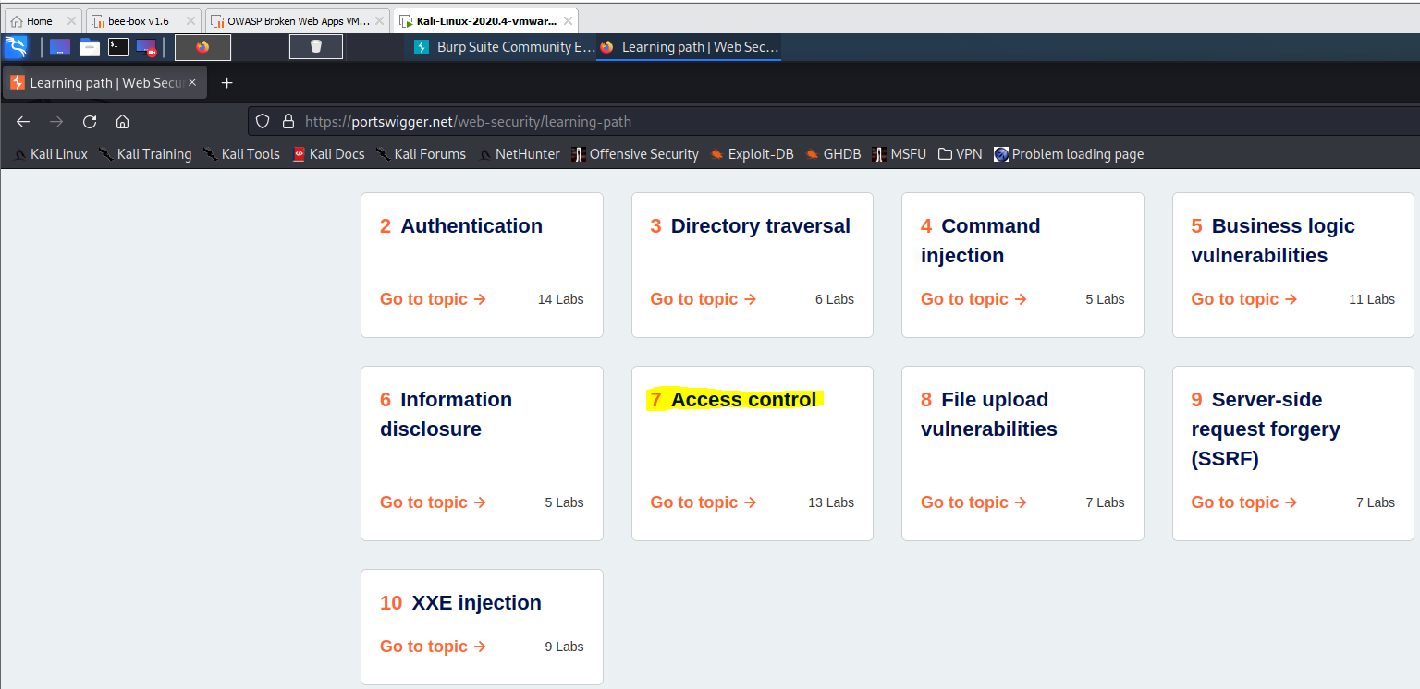

Take time to go through the details on “Access control vulnerabilities and privilege escalation”. Broken access control vulnerabilities exist when a user can in fact access some resource or perform some action that they are not supposed to be able to access.

# Vertical privilege escalation

If a user can gain access to functionality that they are not permitted to access, then this is vertical privilege escalation. For example, if a non-administrative user can in fact gain access to an admin page where they can delete user accounts, then this is vertical privilege escalation.

## Unprotected functionality

At its most basic, vertical privilege escalation arises where an application does not enforce any protection over sensitive functionality. For example, administrative functions might be linked from an administrator's welcome page but not from a user's welcome page. However, a user might simply be able to access the administrative functions by browsing directly to the relevant admin URL.

For example, a website might host sensitive functionality at the following URL:

https://insecure-website.com/admin

This might in fact be accessible by any user, not only administrative users who have a link to the functionality in their user interface. In some cases, the administrative URL might be disclosed in other locations, such as the robots.txt file:

https://insecure-website.com/robots.txt

Even if the URL isn't disclosed anywhere, an attacker may be able to use a wordlist to brute-force the location of the sensitive functionality - the dirb tool.

### **Lab 1: Unprotected admin functionality**

**NOTE: Read through the steps below, before proceeding to do the lab.** Since these Labs are provisioned in the cloud, they will time out very quickly. Once timed out, you need to click “Access the lab” again, and in doing so you will be given a different Lab URL, and you may have to repeat these steps. To limit this inconvenience as much as possible, please read through the steps below, before proceeding to do the lab.

Take time to read the instructions and details provided for this Lab. Click on the link “Unprotected admin functionality”. This lab has an unprotected admin panel. Solve the lab by deleting the user carlos.

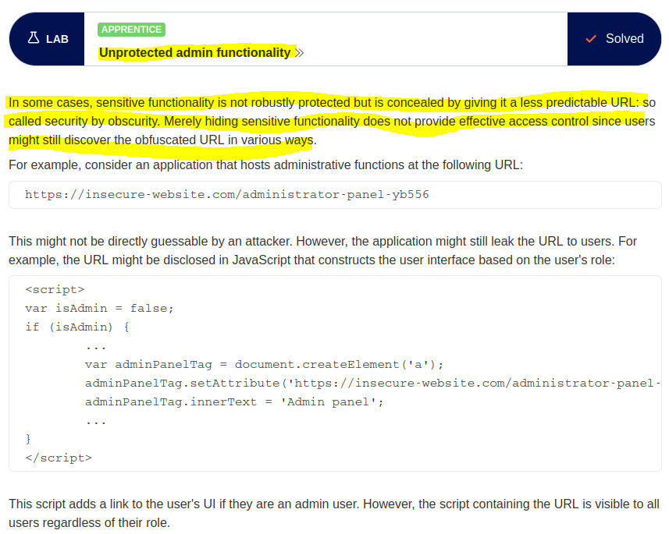

Right click on “Access the lab” and select “Open Link in New Tab”. This would allow you to come back to this tab in case you want to refer to the “Solution” or “Community Solutions” for this particular Lab.

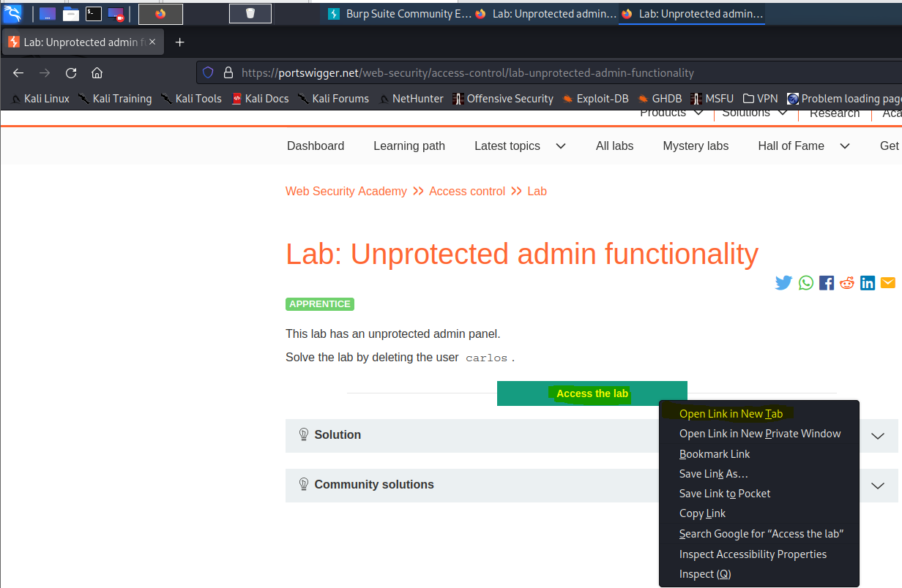

Copy the URL displayed on your Kali Linux Web Browser’s address bar. NOTE: Your URL would be different from the one seen in the screenshot below.

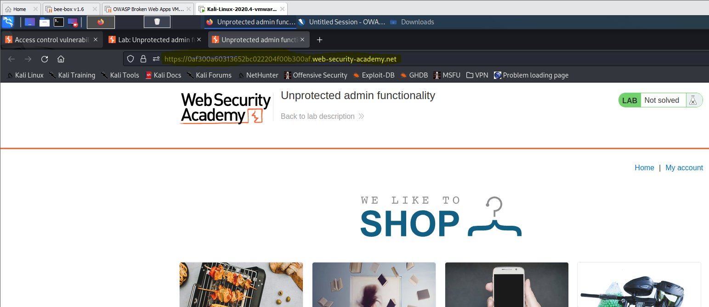

In some cases, sensitive functionality is not robustly protected but is concealed by giving it a less predictable URL: so called security by obscurity. Merely hiding sensitive functionality does not provide effective access control since users might still discover the obfuscated URL in various ways. To know about the different URLs in a website, we can Spider this website. Unfortunately, Burp Suite Community Edition does not come with Spidering feature. Therefore, we will use OWASP ZAP to Spider the above website.

#### Spidering using OWASP ZAP

##### Launch OWASP ZAP

Before you launch OWASP ZAP, make sure that **Burp Suite is not running (Quit/Terminate Burp Suite)**. Click on Kali Linux logo at the top left corner of the Desktop, and search for “ZAP”. Click on “OWASP ZAP” to launch the OWASP ZAP. NOTE: The other ZAP you may see on the top is your older version.



Select: No, I do not want to persist this session at this moment in time, and Click “Start”



Click “Automated Scan”

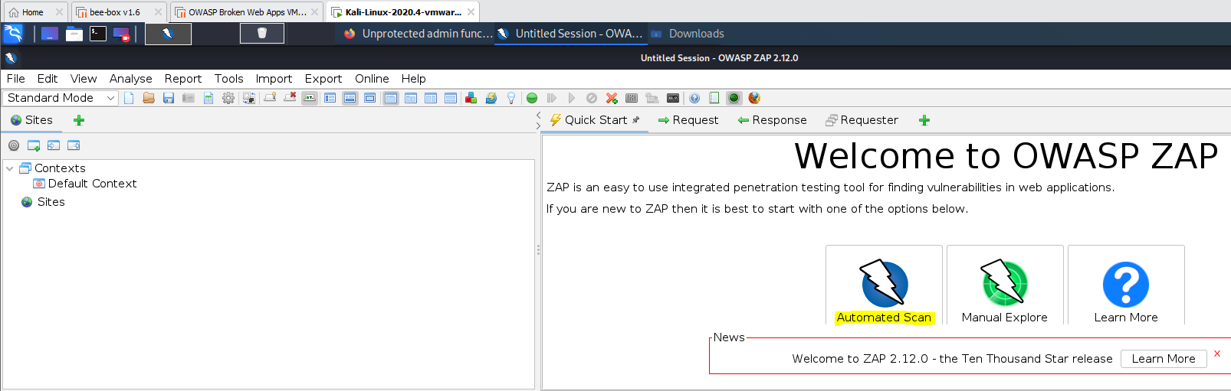

Paste the Lab 1 URL that you had copied above under the “URL to attack:”. Select “Use traditional spider:” and click “Attack”

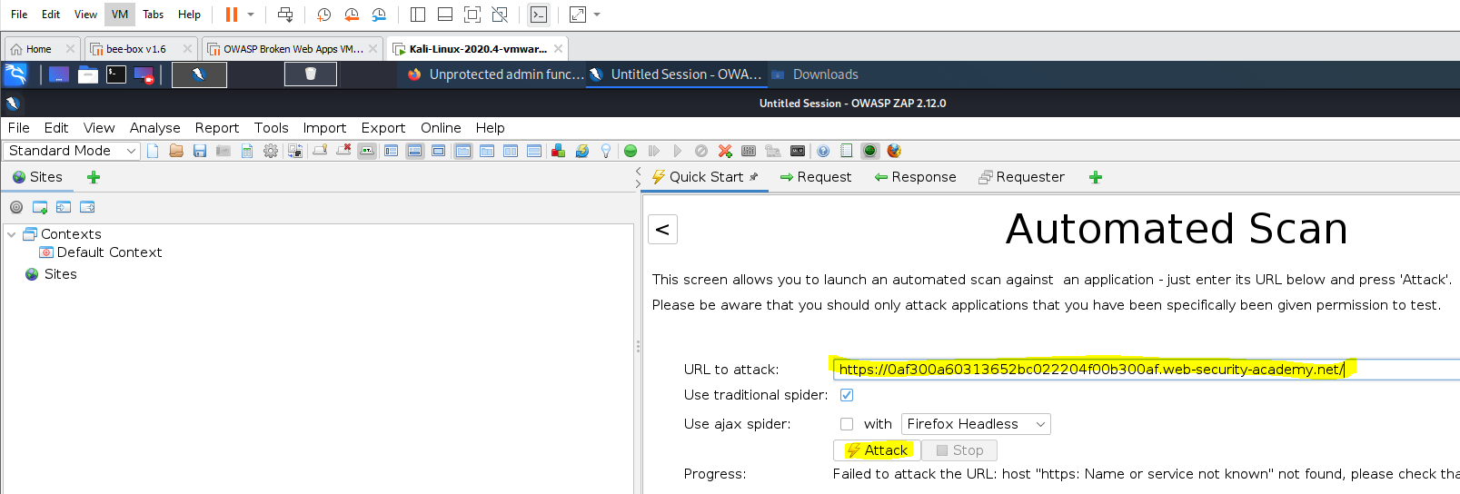

Click on “Spider” tab and once the progress bar reaches 100%, you can click on “Stop”. On the left pane expand “Sites”, and the “Lab 1 URL” folder.

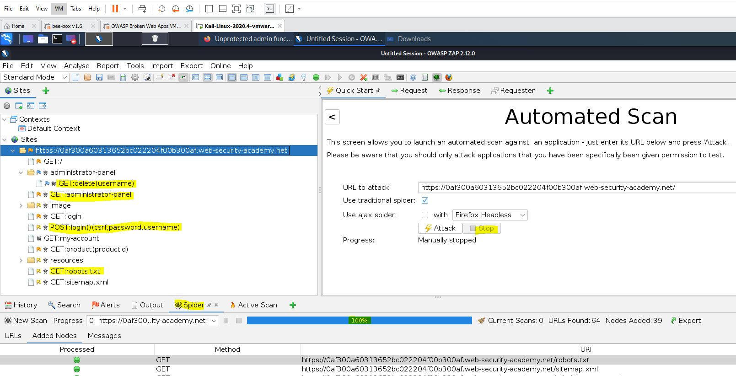

We can observe the following important details:

* GET:robots.txt
* GET:delete(username)
* GET:administration-panel
* POST:login()(CSRF,password,username)

[NOTE: We will not explore POST:login()(CSRF,password,username), since we covered this type of vulnerability in our previous practical on “Identification and Authentication Failures”.]

Right click on “GET:robots.txt” and select “Open URL in System Browser”

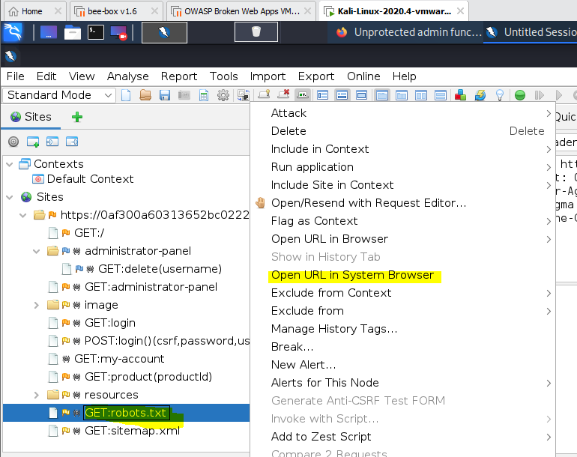

Basically, the address bar will have: https://LAB1_URL/robots.txt.

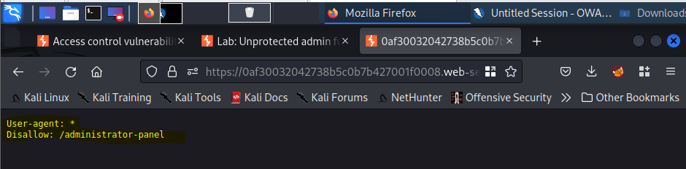

robots.txt is placed on most of the websites (https://DOMAIN_NAME/robots.txt) to inform the search crawlers which of its webpages are allowed or disallowed to be crawled. It is expected that crawlers obey the instructions in this robots.txt. However, robots.txt can reveal sensitive information.

If you study the Lab 1 website, you will only see links such as: “Home”, “My account”, and various products’ “View details”. We see no visible link indicating an admin panel. However, the robots.txt clearly reveals that there is indeed a hidden “/administration-panel” page with Disallow tag.

Our OWASP ZAP spidering also detected these hidden pages such as: GET:administration-panel, and GET:delete(username). Right click on GET:administration-panel, and select “Open URL in System Browser”. You will be presented with a webpage where you can click “Delete” to delete the user, Carlos. This concludes the challenge.

Lab 1 teaches us that “Broken Access Control”, can allow even a non-admin user to perform admin tasks such as deleting a user.

### **Lab 2:** **Unprotected admin functionality with unpredictable URL**

**NOTE: Read through the steps below, before proceeding to do the lab.**

Take time to read the instructions and details provided for each Lab. Click on the link “Unprotected admin functionality with unpredictable URL”. This lab has an unprotected admin panel. It's located at an unpredictable location, but the location is disclosed somewhere in the application. Solve the lab by accessing the admin panel, and using it to delete the user carlos.

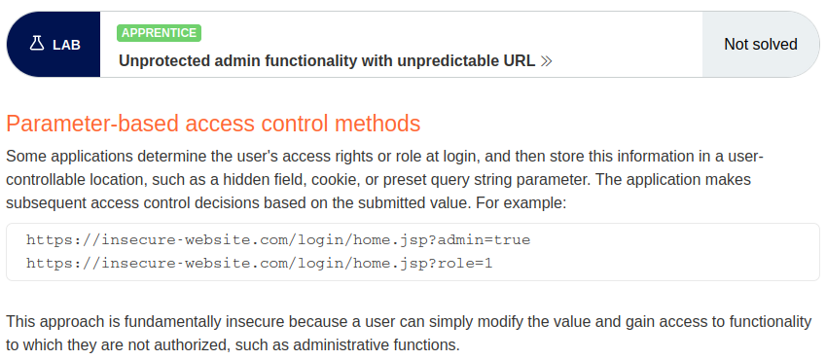

Since this Lab states that there is an unprotected admin panel, at an unpredictable location, Spidering may not give us any valuable information. Therefore, we skip Spidering using OWASP ZAP and proceed to use Burp Suite to examine this website.

#### Launch Burp Suite

Before you launch Burp Suite, make sure that **OWASP ZAP is not running (Quit/Terminate OWASP ZAP)**. Click on Kali Linux logo at the top left corner of the Desktop, and search for “burp”. Click on “Burp Suite Community Edition” to launch the Burp Suite



#### Prepping Up Burp Suite

Click on “Proxy” tab 🡪 “Intercept” tab. Click on the button “Intercept is on” to toggle it to “Intercept is off”. With this setting Burp Suite will not be intercepting requests and responses between the Kali Linux Web Browser and a webserver. With “Intercept is off” Burp Suite will be in listener mode, where it will just listen and record all the requests and responses made between the Kali Linux Web Browser and a webserver

|  |  |
| --- | --- |
|  |  |

Click on “HTTP history” tab, if you notice any records listed in the top pane, right click on the top row record, and click “Clear history”. This would make “HTTP history” tab clear with no previously recorded requests and responses between the Kali Linux Web Browser and a webserver.

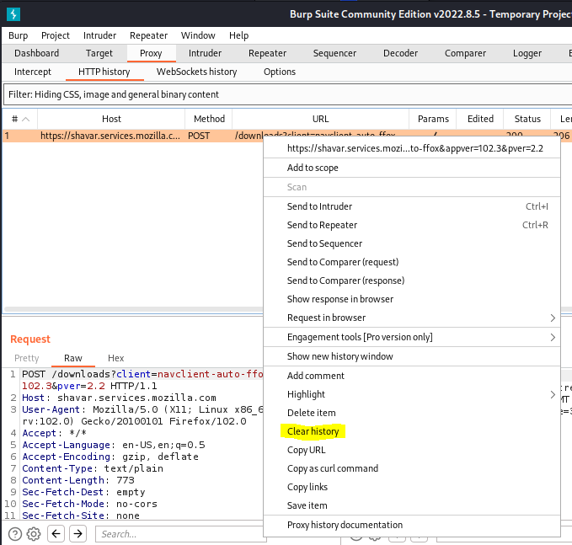

Click “Yes”

|  |  |
| --- | --- |
|  |  |

Right click on “Access the lab” and select “Open Link in New Tab”. This would allow you to come back to this tab in case you want to refer to the “Solution” or “Community Solutions” for this particular Lab.

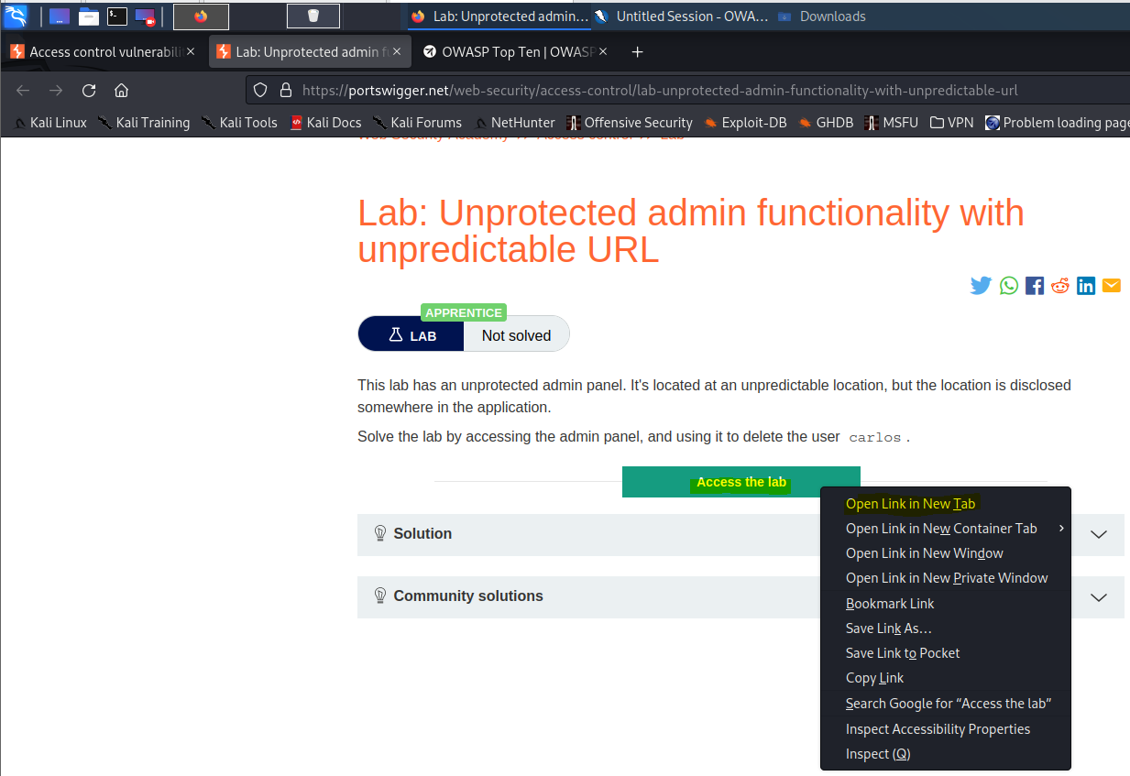

This GET Request is recorded in the “HTTP history”. Select this GET Request on the top pane and click on the “Response” tab in the bottom pane. Scroll down and you will notice that the webserver has Responded (along with other HTML and CSS code) with a JavaScript (JS) code. This JS code indicates that the GET Request, the webserver just received is not from an Admin (isAdmin = false), this is correct, because we did not login as Admin when we sent the GET Request. The JS code further indicates that only if the GET Request is from Admin, only then a Hyper Link “Admin Panel” will appear on the landing page pointing to /admin-z4nkk3 [NOTE: this hyper link will be different for you, as it is randomly generated].

Therefore, by studying this JS code sent by the webserver in its Response to our GET Request, the location of the Admin Panel, which is /admin-z4nkk3 (in this case) is revealed.

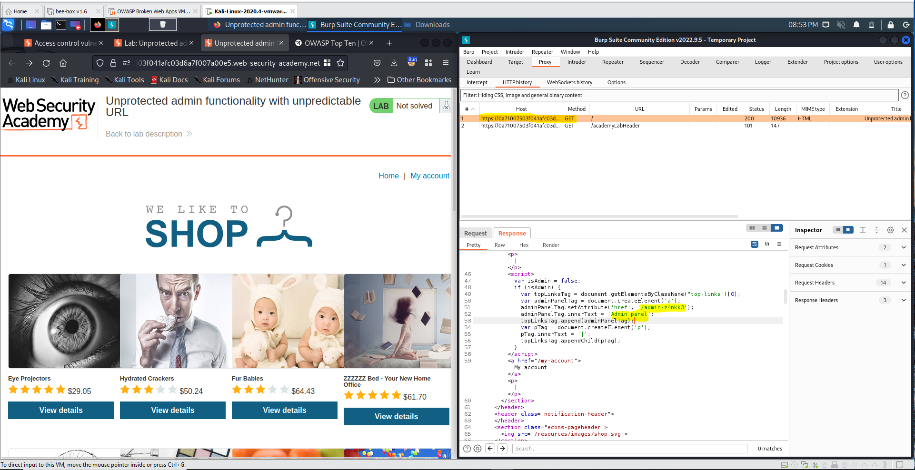

Copy and paste /admin-z4nkk3 into your Kali Linux Web Browser’s address bar as shown in the screenshot below and press Enter.

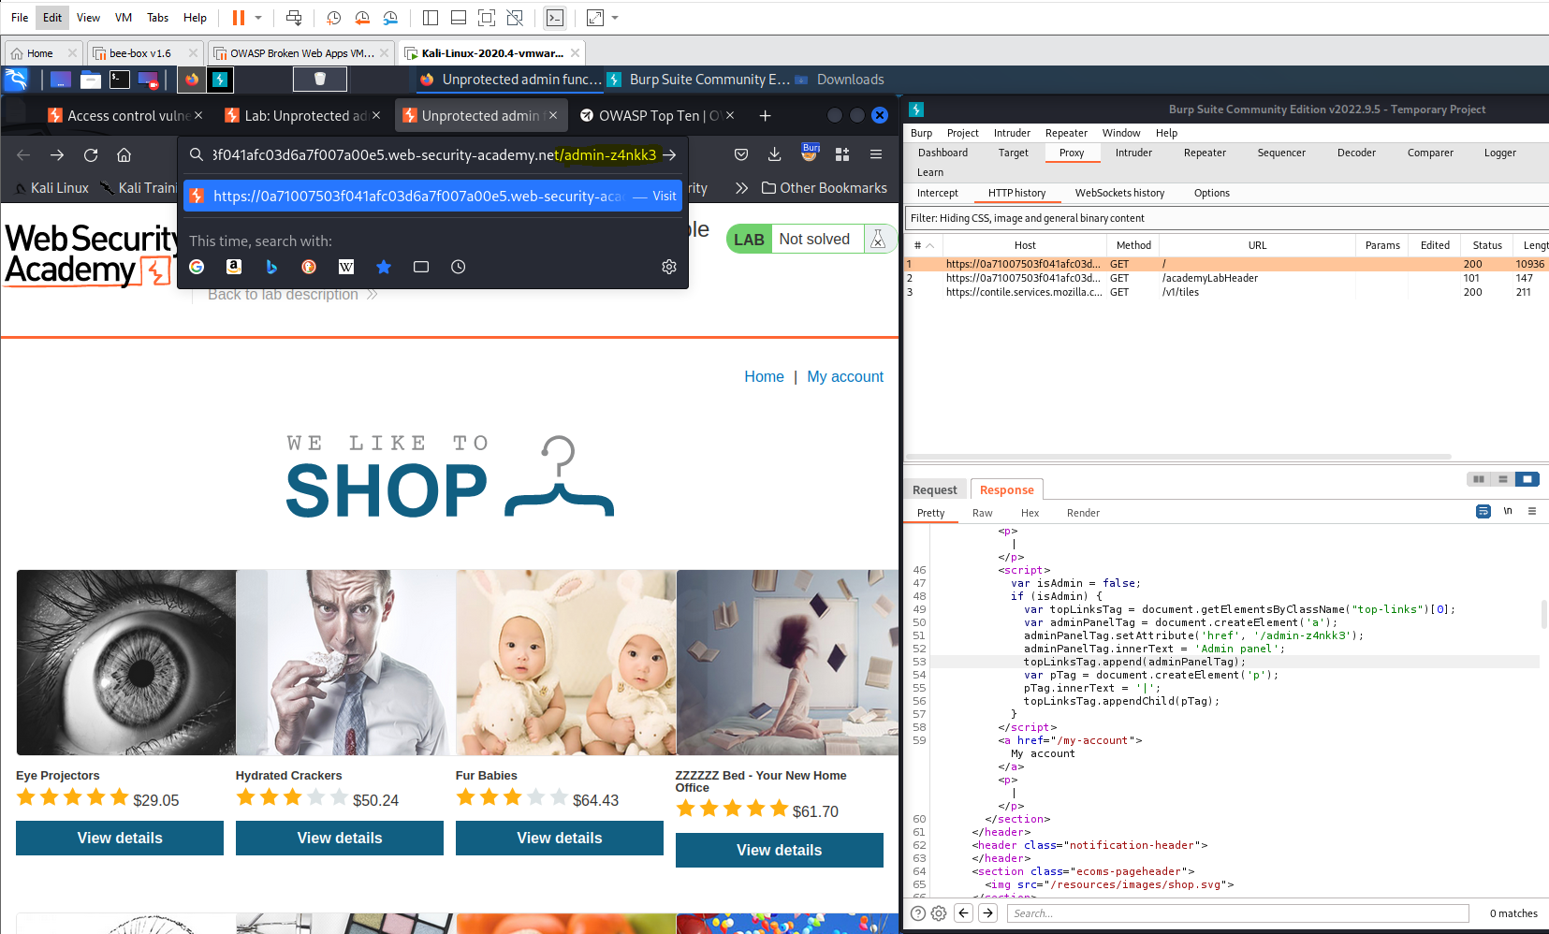

You will be directed to the Admin Panel as shown below. Click Delete next to Carlos.

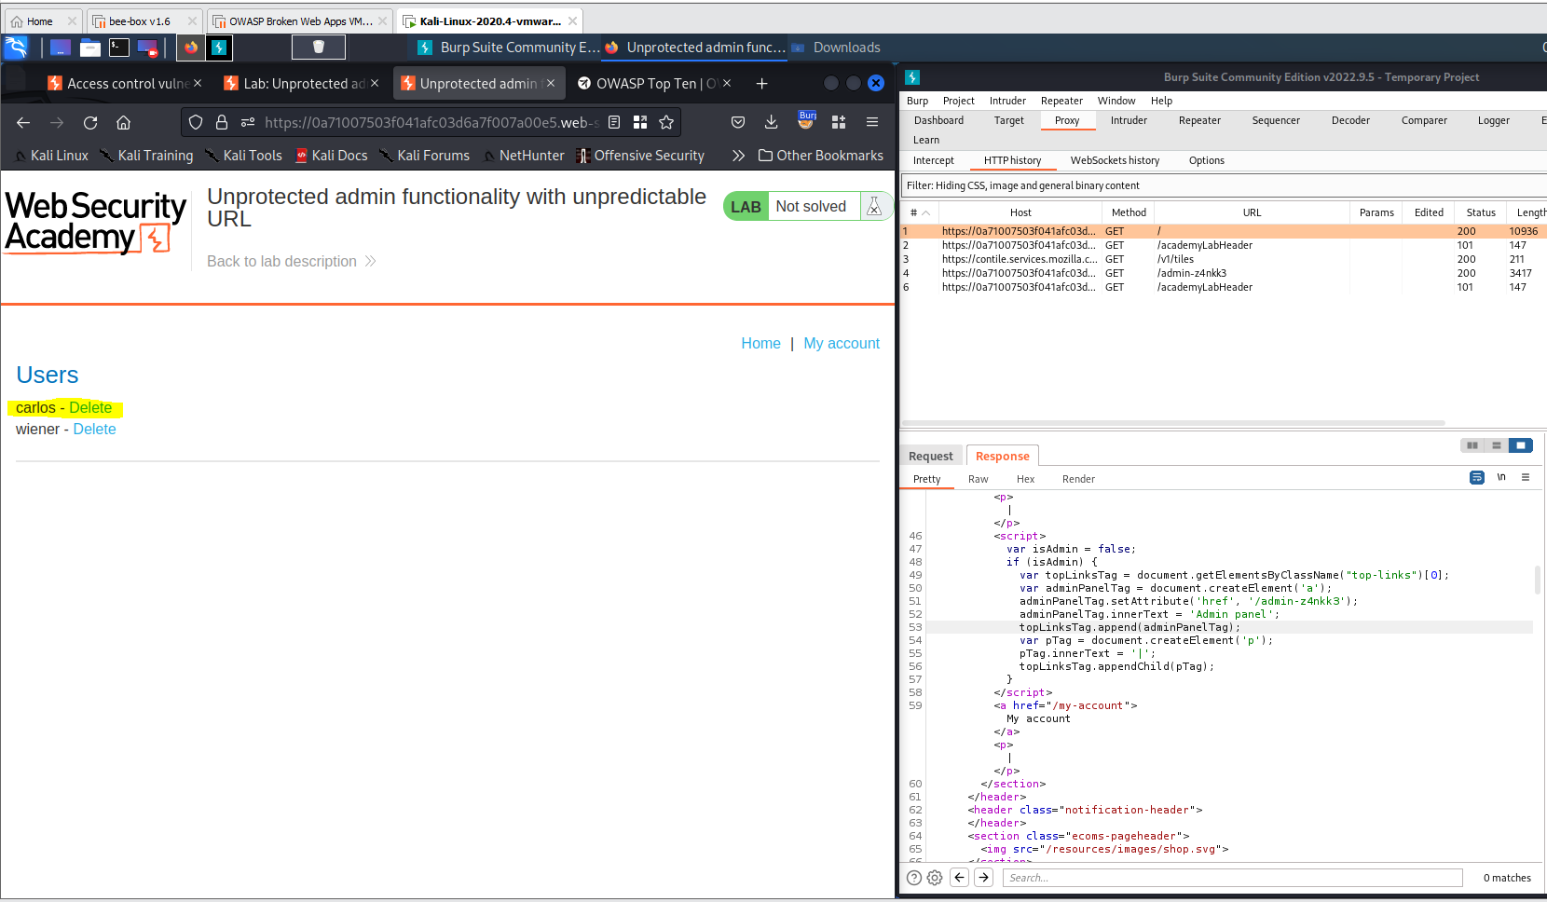

Once the user Carlos is deleted, you will see this Congratulatory message from the webserver.

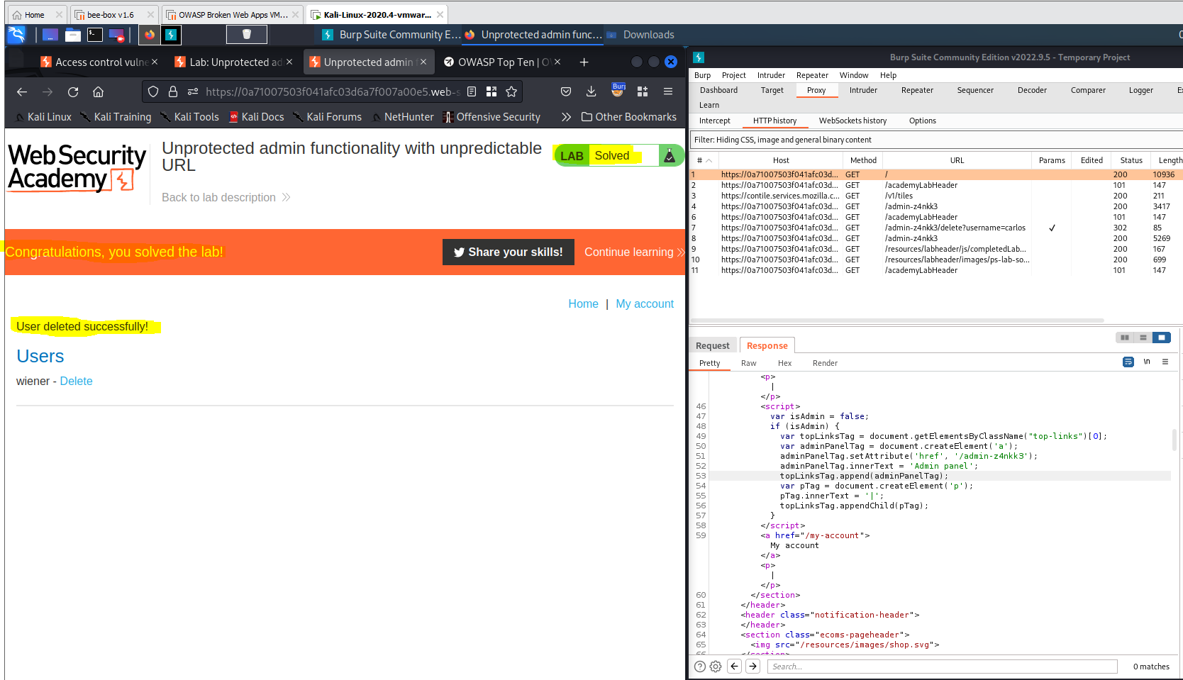

## Parameter-based access control methods

Some applications determine the user's access rights or role at login, and then store this information in a user-controllable location, such as a hidden field, cookie, or preset query string parameter. The application makes subsequent access control decisions based on the submitted value. For example:

https://insecure-website.com/login/home.jsp?admin=true

https://insecure-website.com/login/home.jsp?role=1

This approach is fundamentally insecure because a user can simply modify the value and gain access to functionality to which they are not authorized, such as administrative functions.

### **Lab3: User role controlled by request parameter**

**NOTE: Read through the steps below, before proceeding to do the lab.**

Click on the link “User role controlled by request parameter”. This lab has an admin panel at /admin, which identifies administrators using a forgeable cookie. Solve the lab by accessing the admin panel and using it to delete the user carlos. You can log in to your own account using the following credentials: wiener:peter

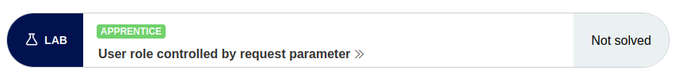

#### Launch Burp Suite

Before you launch Burp Suite, make sure that **OWASP ZAP is not running (Quit/Terminate OWASP ZAP)**. Click on Kali Linux logo at the top left corner of the Desktop, and search for “burp”. Click on “Burp Suite Community Edition” to launch the Burp Suite



#### Prepping Up Burp Suite

Click on “Proxy” tab 🡪 “Intercept” tab. Click on the button “Intercept is on” to toggle it to “Intercept is off”. With this setting Burp Suite will not be intercepting requests and responses between the Kali Linux Web Browser and a webserver. With “Intercept is off” Burp Suite will be in listener mode, where it will just listen and record all the requests and responses made between the Kali Linux Web Browser and a webserver

|  |  |
| --- | --- |
|  |  |

Click on “HTTP history” tab, if you notice any records listed in the top pane, right click on the top row record, and click “Clear history”. This would make “HTTP history” tab clear with no previously recorded requests and responses between the Kali Linux Web Browser and a webserver.



Click “Yes”

|  |  |
| --- | --- |
|  |  |

Right click on “Access the lab” and select “Open Link in New Tab”. This would allow you to come back to this tab in case you want to refer to the “Solution” or “Community Solutions” for this particular Lab.

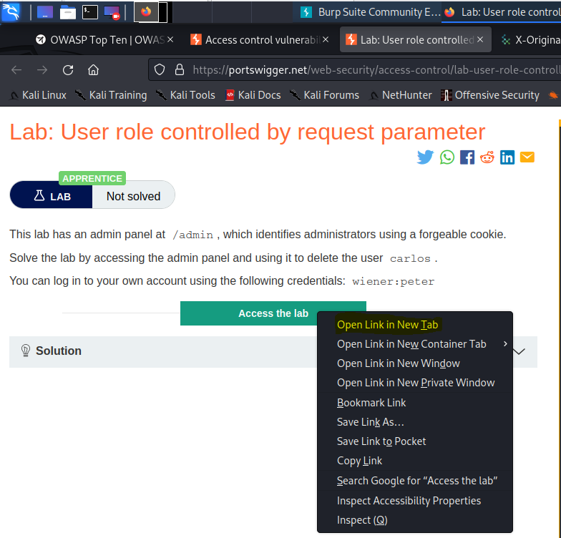

This lab has an admin panel at /admin: Browse to /admin and observe that you can't access the admin panel. Click on “My Account”

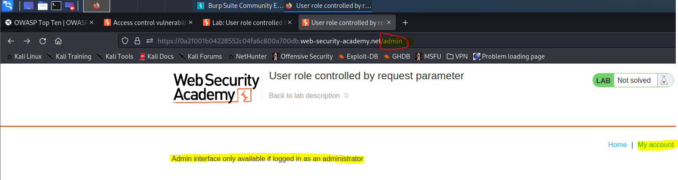

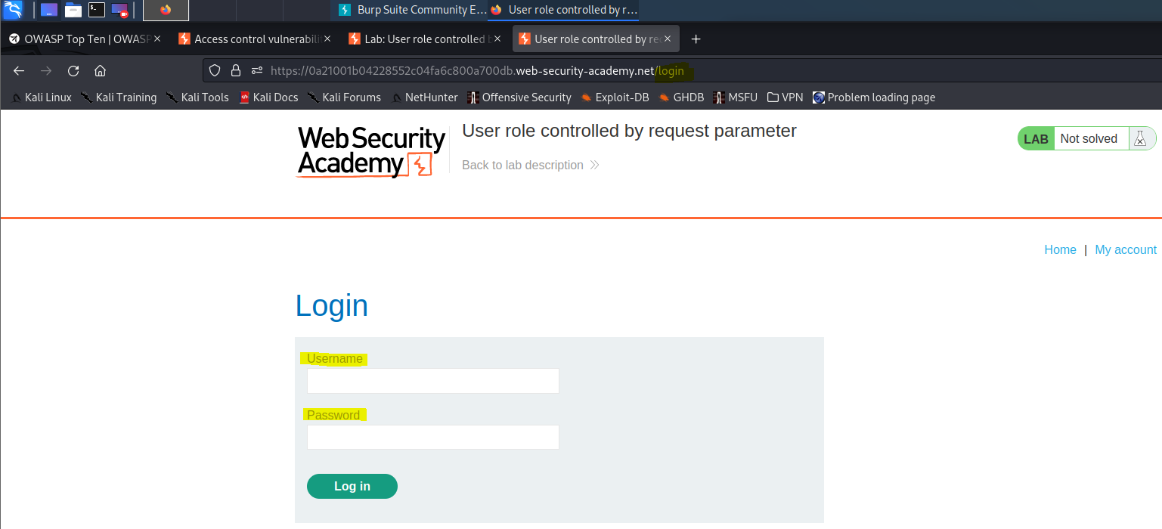

In Burp Suite, click on the “Proxy” tab 🡪 click “Intercept” 🡪 turn interception on “Intercept is on”. Click on Options, scroll down, and under the “Intercept Service Responses”, check “Intercept responses based on …”. By doing do, Burp Suite will now begin to intercept webserver responses as well.

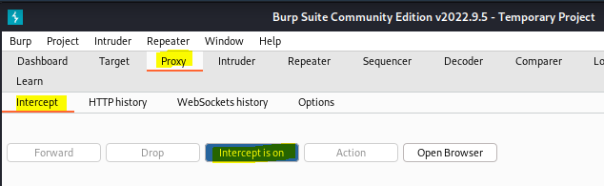

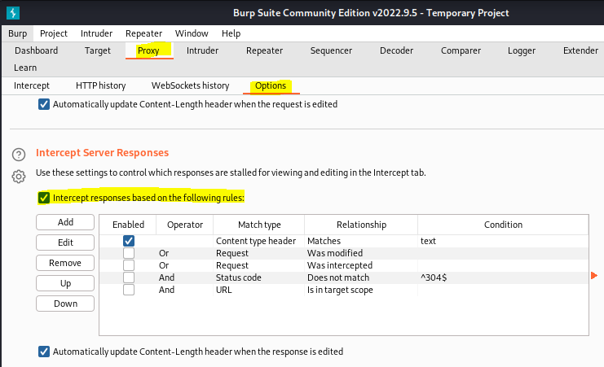

You can log in to your own account using the following credentials: wiener:peter. Complete and submit the login page with Username: wiener, and Password: peter.

This POST Request is intercepted by Burp Proxy. Click “Forward” to allow this POST Request to reach the webserver.

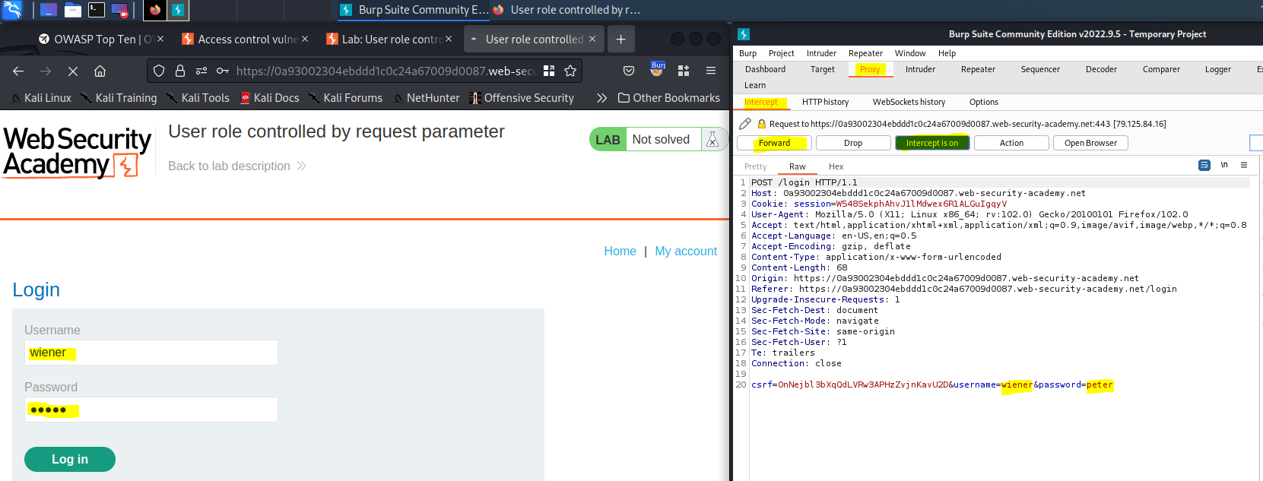

The Response from the webserver is intercepted by Burp Proxy. You can notice that the webserver is setting a cookie, with a session ID and Admin=false, this is because the submitted username: wiener and password: peter are not Admin credentials. Forwarding this response as is, to the Kali Linux’s Web Browser, will not allow us to access the Admin Panel.

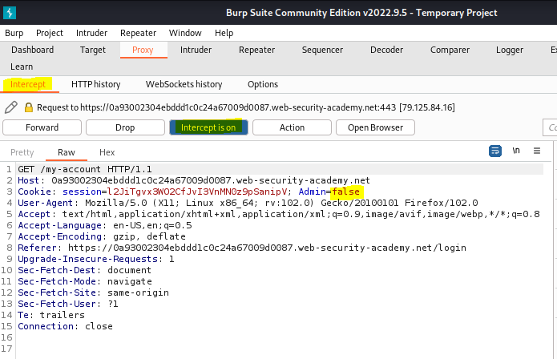

Therefore, before clicking the “Forward” button, let us replace “false” with “true”.

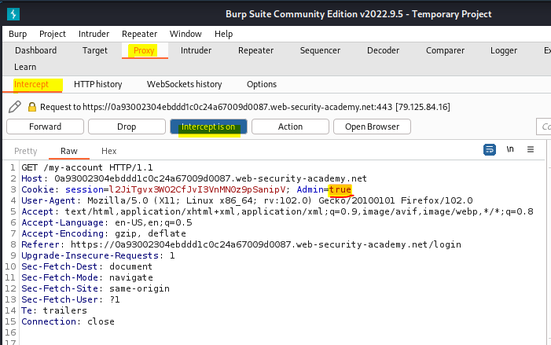

Click the “Forward” button a few times.

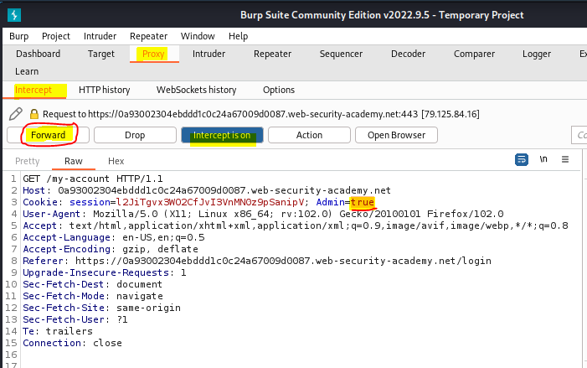

You will notice that a Link “Admin panel” appears. Even though the username: wiener is not an Admin, by changing the cookie detail to “Admin=true”, allowed us to make the “Admin panel” link appear as if wiener is an Admin.

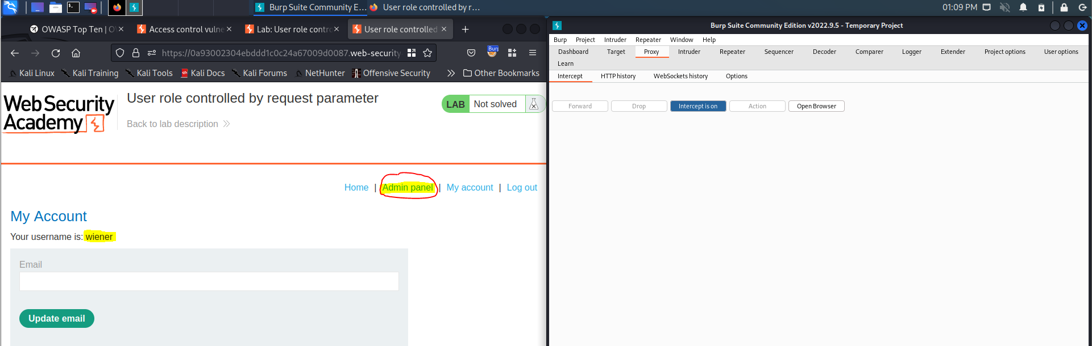

Now click on the link: “Admin panel”. In this GET Request, that gets intercepted by Burp Proxy, you will notice that Admin=false. If this GET Request reaches the webserver it is not going to allow us access to the Admin Panel because the Cookie being sent by your Kali Linux’s Web Browser is indicating Admin=false.

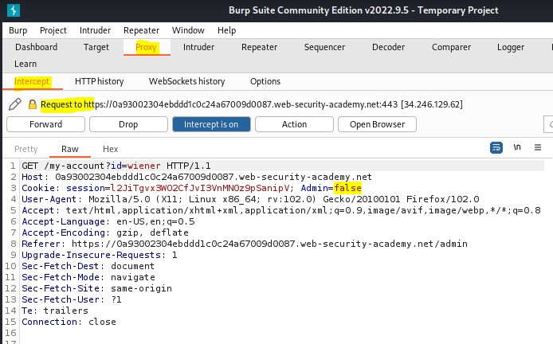

We need to edit the Cookie: by replacing Admin=false to Admin=true.

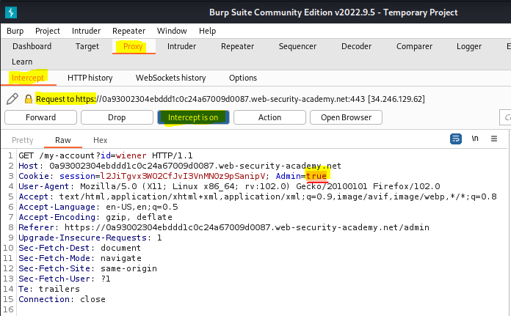

Now click the “Forward” button a few times until the Admin Panel is displayed on your Kali Linux’s Web Browser.

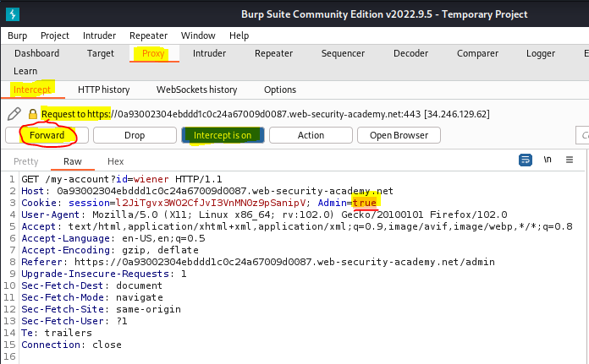

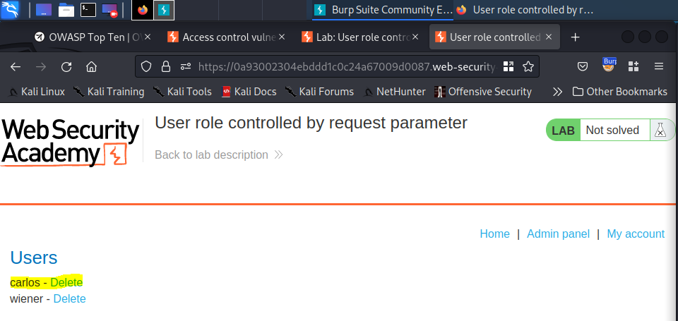

Now click “Delete” that is next to the name carlos. This GET Request will again be intercepted by Burp Proxy, and you will have to replace Admin=false to Admin=true, and then click “Froward” button. From now on whenever, you notice in the intercept Admin=false, keep changing it to Admin=true for a few times and click Forward.

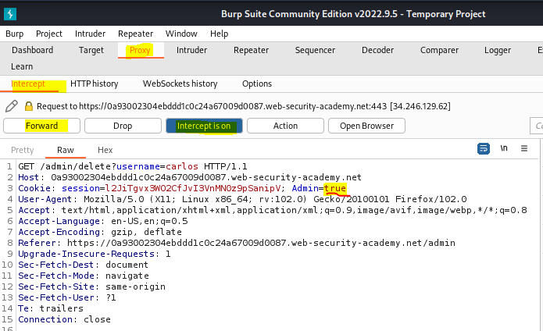

Congratulations, you solved the lab!

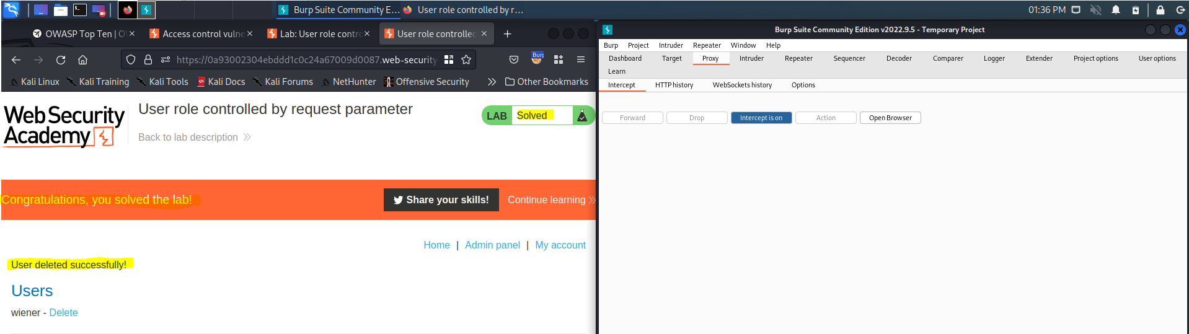

If you are tired of manually changing Request Header’s Admin=false to Admin=true. Try redoing certain parts of this Lab using the Burp Proxy’s “Match and Replace“ feature. This will automatically change Admin=true inside all the Request Headers. In the “Replace” text field below, copy and paste your Cookie string, but replace Admin=false to Admin=true. After doing this you will see that it is so easy to auto replace Admin=false to Admin=true in all the intercepts.

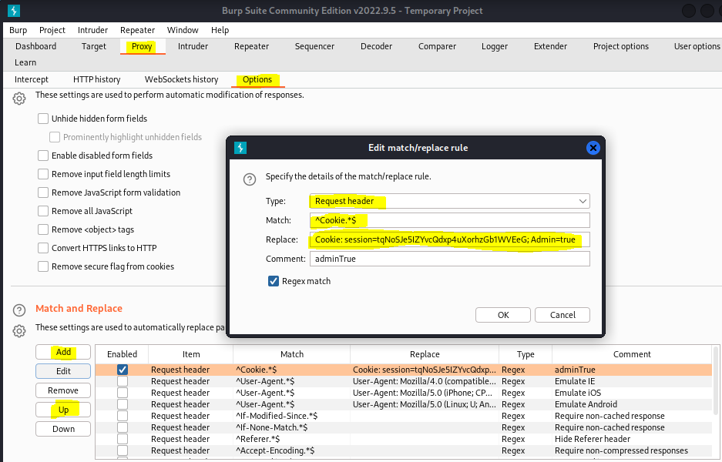

After trying this out make sure you uncheck this entry so that it does not affect your future labs.

### **User role can be modified in user profile**

**NOTE: Read through the steps below, before proceeding to do the lab.**

Click on the link “User role can be modified in user profile”. This lab has an admin panel at /admin. It's only accessible to logged-in users with a roleid of 2. Solve the lab by accessing the admin panel and using it to delete the user carlos. You can log in to your own account using the following credentials: wiener:peter

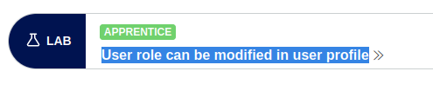

#### Launch Burp Suite

Before you launch Burp Suite, make sure that **OWASP ZAP is not running (Quit/Terminate OWASP ZAP)**. Click on Kali Linux logo at the top left corner of the Desktop, and search for “burp”. Click on “Burp Suite Community Edition” to launch the Burp Suite



#### Prepping Up Burp Suite

Click on “Proxy” tab 🡪 “Intercept” tab. Click on the button “Intercept is on” to toggle it to “Intercept is off”. With this setting Burp Suite will not be intercepting requests and responses between the Kali Linux Web Browser and a webserver. With “Intercept is off” Burp Suite will be in listener mode, where it will just listen and record all the requests and responses made between the Kali Linux Web Browser and a webserver

|  |  |
| --- | --- |
|  |  |

Click on “HTTP history” tab, if you notice any records listed in the top pane, right click on the top row record, and click “Clear history”. This would make “HTTP history” tab clear with no previously recorded requests and responses between the Kali Linux Web Browser and a webserver.



Click “Yes”

|  |  |
| --- | --- |
|  |  |

Right click on “Access the lab” and select “Open Link in New Tab”. This would allow you to come back to this tab in case you want to refer to the “Solution” or “Community Solutions” for this particular Lab.

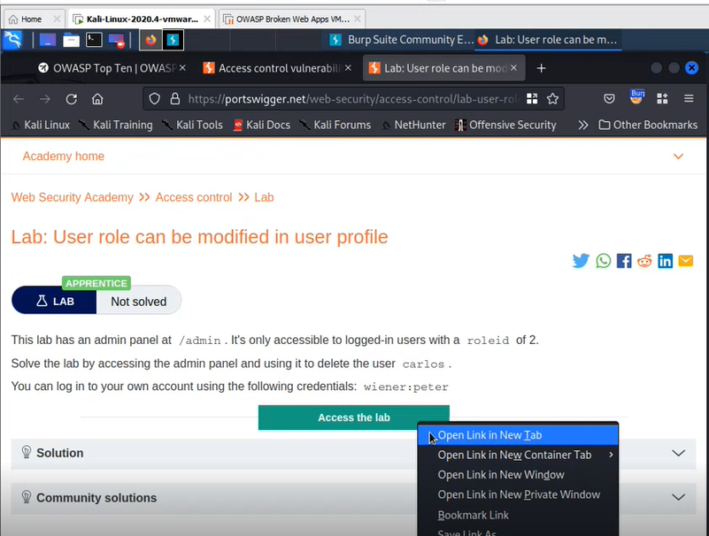

In the Burp Suite, click on the “Target” tab, in the “Site map”, right click on this Lab’s URL and select “Add to scope”. This would enable Burp Suite to only focus on this Lab’s URL when it is intercepting or recording the HTTP Requests and Responses. We can cut out a lot of noise if we do this.

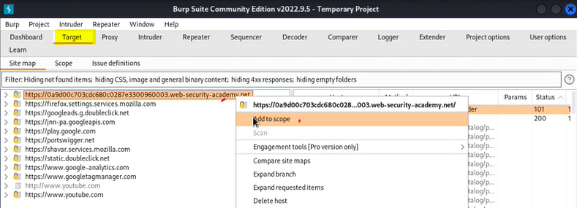

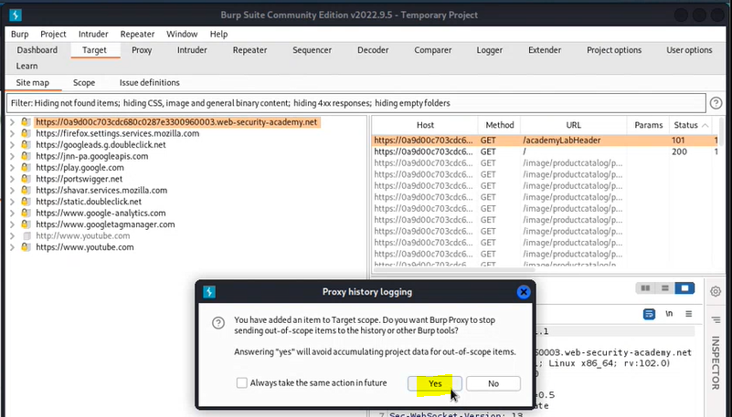

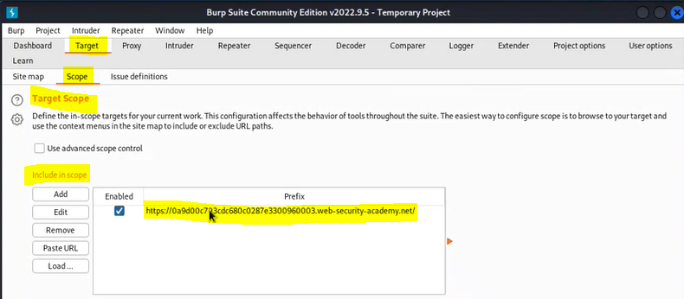

Just in case before we start, make sure, in the Burp “Proxy” tab, under the “HTTP history”, right click on any existing row (if any) in the top pane and select “Clear History”.

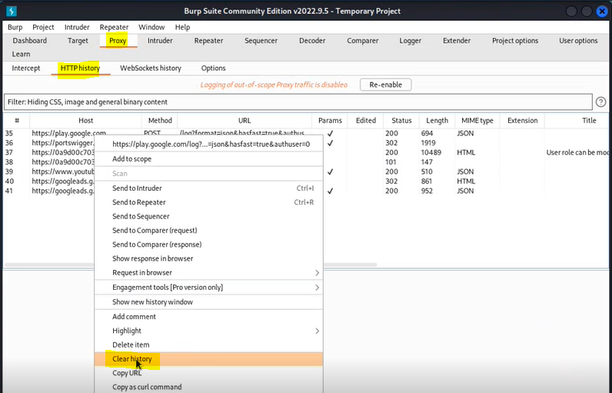

Also make sure your “Intercept is off”

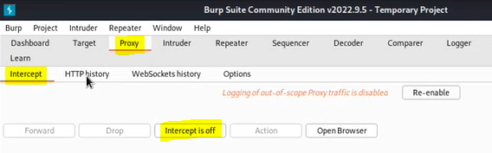

Click on the “My account”

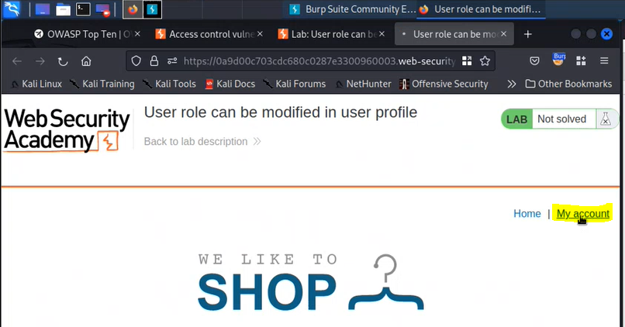

Login using the Username: Wiener, and Password: peter.

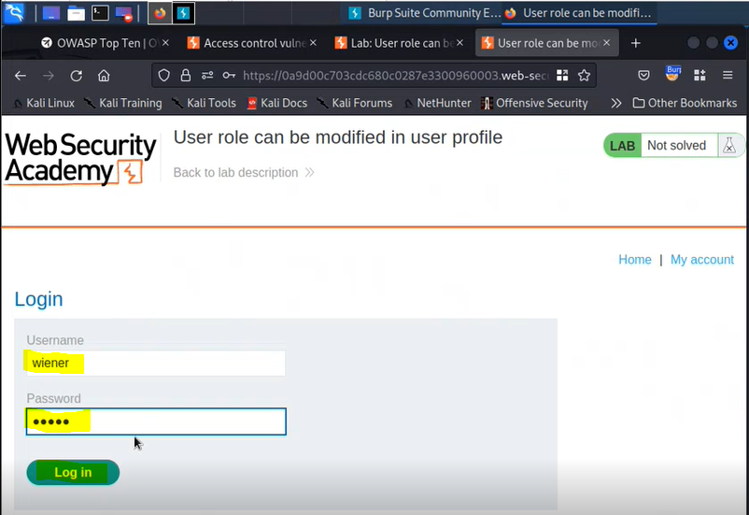

Once done you will notice “Wiener’s” landing page. On this lading page there is no Link: “Admin panel”, this is because Wiener may not belong to the roleid of 2. But what is Wiener’s roleid?

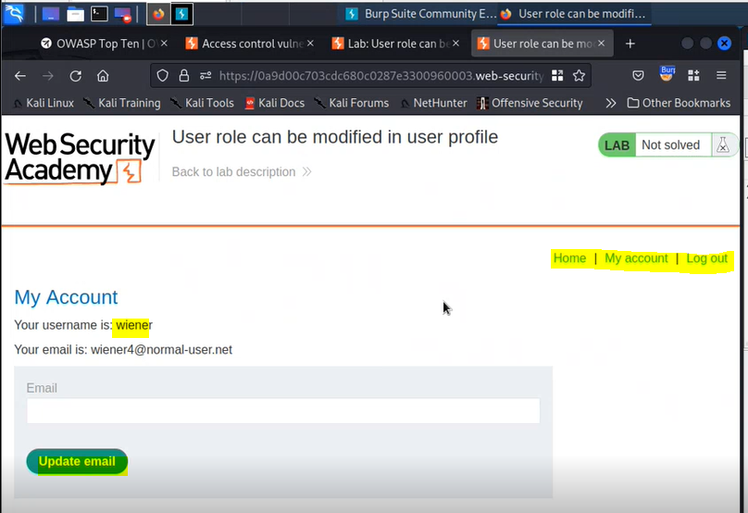

This lading page offers Wiener the option to “Update (his) email”. Type in a random email ID such as [wiener5@normal-user.net](mailto:wiener5@normal-user.net), and click “Update email”.

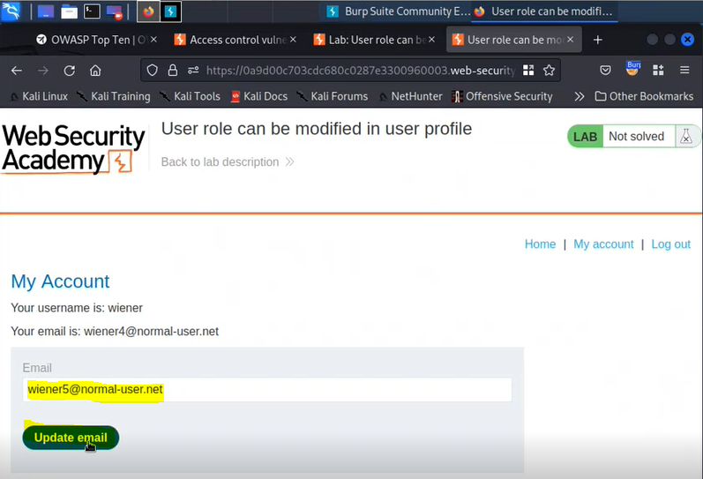

Once the “Update email” is clicked, this GET Request is recoded under the “HTTP history”.

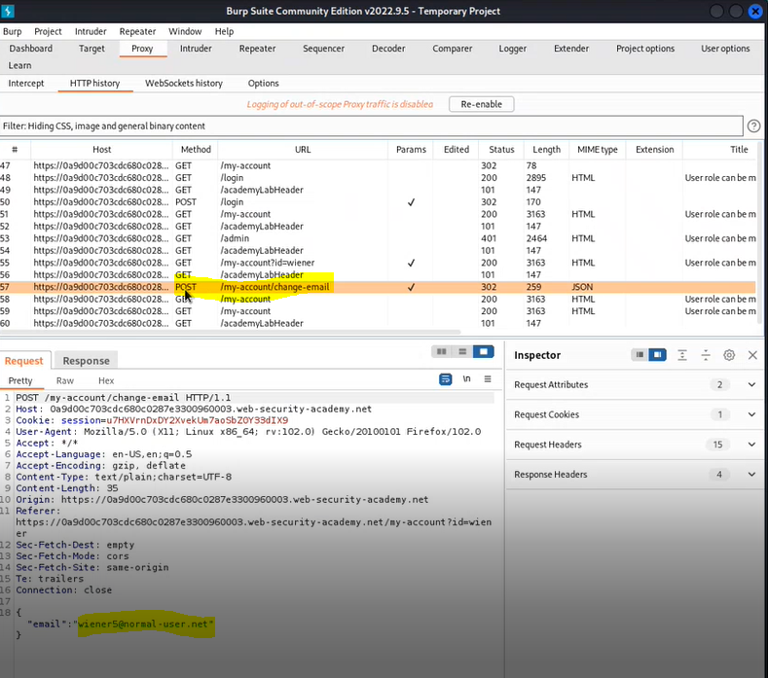

Click on the “Response” tab in the bottom pane. You will notice that the webserver’s response includes a JASON data, where, apart from the other details, the “roleid”:1 of wiener is indicated. Now our aim should be to make wiener’s “roleid”:2

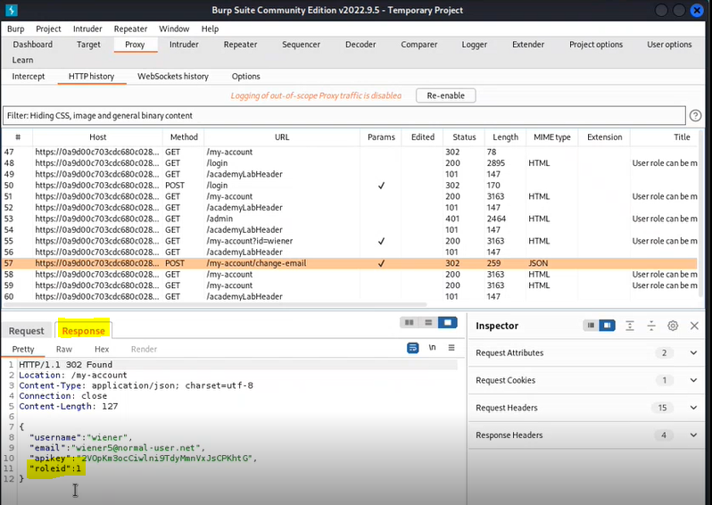

The idea: since the landing page is already providing an email update option, instead of sending to the webserver just one JASON data, which is the email id, we will also send another JASON data “roleid”:2 and see if we are able to update the “roleid” of wiener from “roleid”:1 to “roleid”:2 at the backend. Click on the “Request” tab. Right click on the Request Header and select “Send to Repeater”.

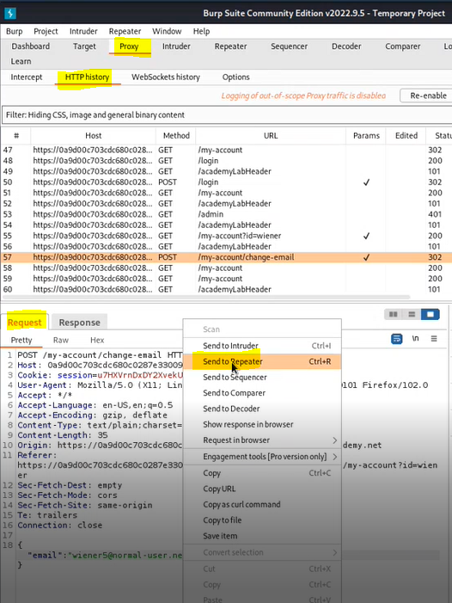

The Burp Repeater will help us to repeat this POST request with both an email ID and the “roleid”:2 set. Edit the JASON data as shown below, don’t miss the comma after the email ID. Click “Send”

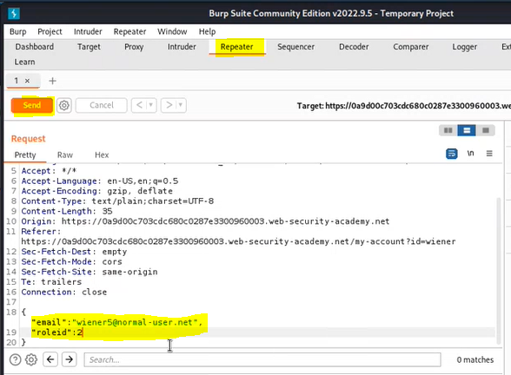

You can notice in the “Response” pane below that webserver is now indicating that wiener’s “roleid”:2. We have thus succeeded.

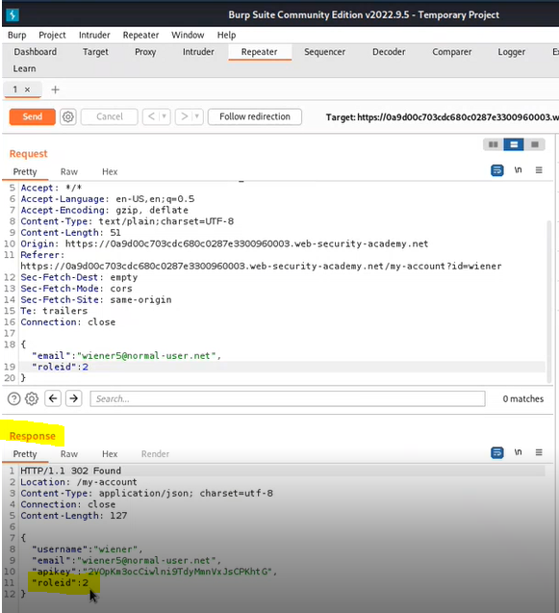

Now refresh the wiener’s landing page you will notice that the link “Admin panel” now appears because the wiener’s “roleid”:2

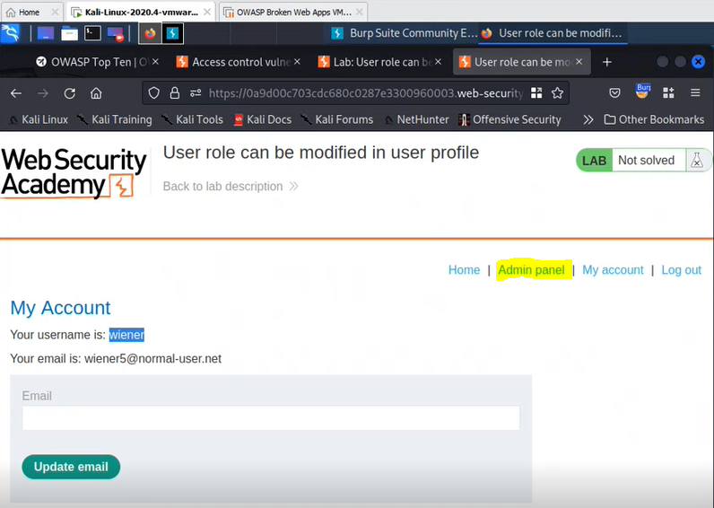

Click on the “Admin panel”, and click “Delete” next to the name carlos

